**How to Install VirtualBox on CentOS 7**

[VirtualBox](https://www.virtualbox.org/) is an open-source cross-platform virtualization software which allows you to run multiple guest operating systems (virtual machines) simultaneously.

In this tutorial, we will show you how to install VirtualBox from the Oracle repositories on CentOS 7 systems.

## Prerequisites

Before continuing with this tutorial, make sure you are logged in as a [user with sudo privileges](https://linuxize.com/post/create-a-sudo-user-on-centos/) .

## Installing VirtualBox from Oracle repositories

Follow the steps below to install VirtualBox on your CentOS 7 machine:

1. Start by downloading the build tools necessary for compiling the vboxdrv kernel module:

sudo yum install kernel-devel kernel-devel-$(uname -r) kernel-headers kernel-headers-$(uname -r) make patch gccCopy

1. Download the Oracle Linux repo file to /etc/yum.repos.d directory using the following [wget command](https://linuxize.com/post/wget-command-examples/) :

sudo wget https://download.virtualbox.org/virtualbox/rpm/el/virtualbox.repo -P /etc/yum.repos.dCopy

1. Install the latest version of VirtualBox 5.2.x by typing:

sudo yum install VirtualBox-5.2Copy

During the installation, you will be prompted to import repository the GPG key. Type y and hit Enter. Once the installation is complete you will see the following output:

Creating group 'vboxusers'. VM users must be member of that group!

Verifying : VirtualBox-5.2-5.2.20_125813_el7-1.x86_64

Installed:

VirtualBox-5.2.x86_64 0:5.2.20_125813_el7-1Copy

1. To verify that your VirtualBox installation was successful, run the following command which will check the status of the vboxdrv service.

systemctl status vboxdrvCopy

The output should look something like this indicating that the service is enabled and active :

● vboxdrv.service - VirtualBox Linux kernel module

Loaded: loaded (/usr/lib/virtualbox/vboxdrv.sh; enabled; vendor preset: disabled)

Active: active (exited) since Thu 2018-10-25 21:31:52 UTC; 6s agoCopy

**To run Virtual Box on CentOS 7**

# VrirtualBox

## Installing VirtualBox Extension Pack

The VirtualBox Extension Pack provides several useful functionalities for guest machines such as virtual USB 2.0 and 3.0 devices, support for RDP, images encryption and more.

At the time of writing this article, the latest version of VirtualBox is 5.2.20. Before downloading the extension pack using the command below you should check the [VirtualBox download page](https://www.virtualbox.org/wiki/Downloads) to see if a newer version is available.  
Download the extension pack file by typing:

wget https://download.virtualbox.org/virtualbox/5.2.20/Oracle_VM_VirtualBox_Extension_Pack-5.2.20.vbox-extpackCopy

When the download is completed import the extension pack using the following command:

sudo VBoxManage extpack install Oracle_VM_VirtualBox_Extension_Pack-5.2.20.vbox-extpackCopy

You will be presented with the Oracle license and prompted to accept the terms and conditions.

Do you agree to these license terms and conditions (y/n)?

Copy

Type y and hit Enter. Once the installation is completed you will see the following output:

0%...10%...20%...30%...40%...50%...60%...70%...80%...90%...100%

Successfully installed "Oracle VM VirtualBox Extension Pack".

Copy

## Starting VirtualBox

Now that you have VirtualBox installed on your CentOS system you can start it either from the command line by typing VirtualBox or by clicking on the VirtualBox icon (Applications -> System Tools -> Oracle VM VirtualBox).

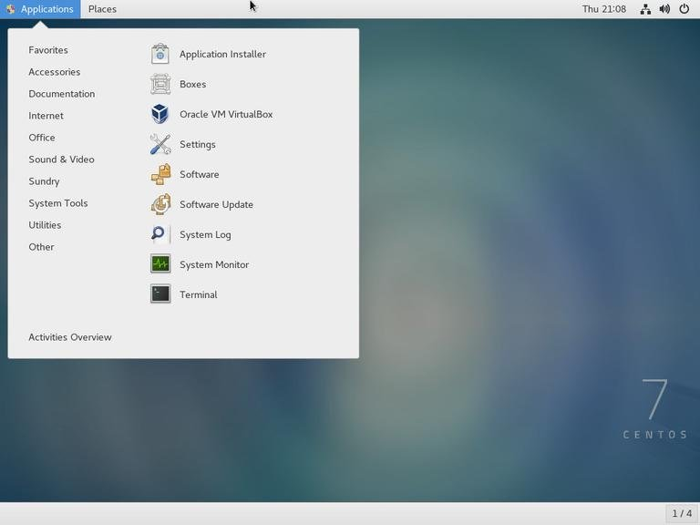

When the VirtualBox is started for the first time, a window like the following should appear:

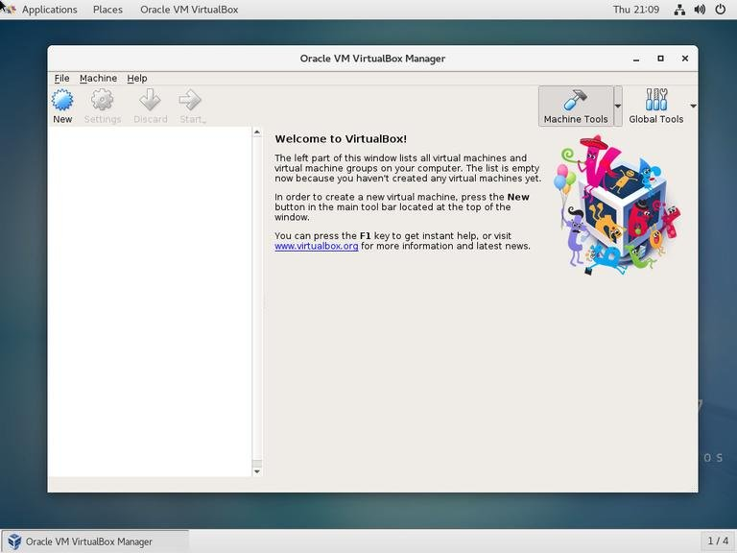

## Conclusion

You have learned how to install VirtualBox on your CentOS 7 machine. You can now install your first Windows or Linux guest machine. To find more information about VirtualBox visit the official [VirtualBox documentation](https://www.virtualbox.org/wiki/Documentation) page.